What is spiderwebbing?
Spiderwebbing is a common feature of beginner mindmaps when chunking is done incorrectly. We call it spiderwebbing because the many arrows and relationships look like spiderwebs between the leaves of a tree.
Spiderwebbing occurs when chunking is not based on the relationships. This is usually because the chunks were formed without order control or importance/retrieval-matching.
As a result, the relationships are scattered and chaotic, reducing retention, increasing the time taken to do the mindmap, overloading intrinsic load and creating lots of unnecessary frustration.
Example
In this example, we have directly chunked in the same way as a textbook. Afterwards, we have identified relationships and tried to represent them.
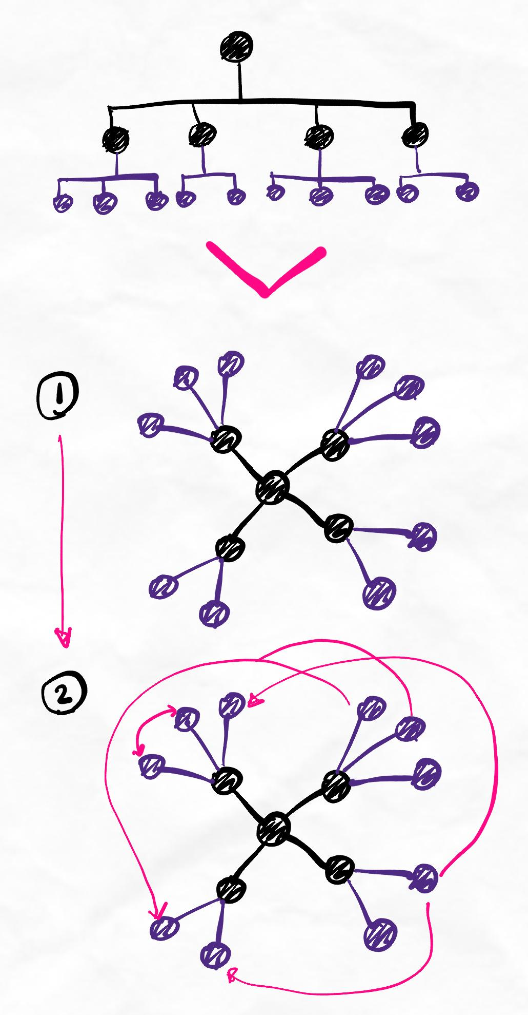
Note that in step 1, this is a pattern of waterfalling as all the connections spread outwards or "down" the hierarchy. There are no lateral relationships.
Attempting to add lateral relationships retroactively causes spiderwebbing in step 2.
Mistake
The mistake was to identify relationships after chunking. Chunks should be formed in the first place by finding relationships and similarities between concepts first, then evaluating the importance of those similarities to decide which groups you could form that are simple and make the most sense.
In this example, the chunks were passively determined based on the textbook hierarchy.
A better way
In the below image, you can see a better way in which the textbook hierarchy is converted to a list, preventing bias in chunking.
Relationships are identified and converted into meaningful chunks.
The resulting map represents all of the relationships from the list. Chunks circled in yellow indicate a unique/new chunk that was formed logically as a result of trying to create the simplest flow. In this way, our network of knowledge represents how we have processed and understood the knowledge, not just what someone else has given to us.
Notice the improvements in flow, directionality, lateral connectivity, and the lack of unnecessary arrows.
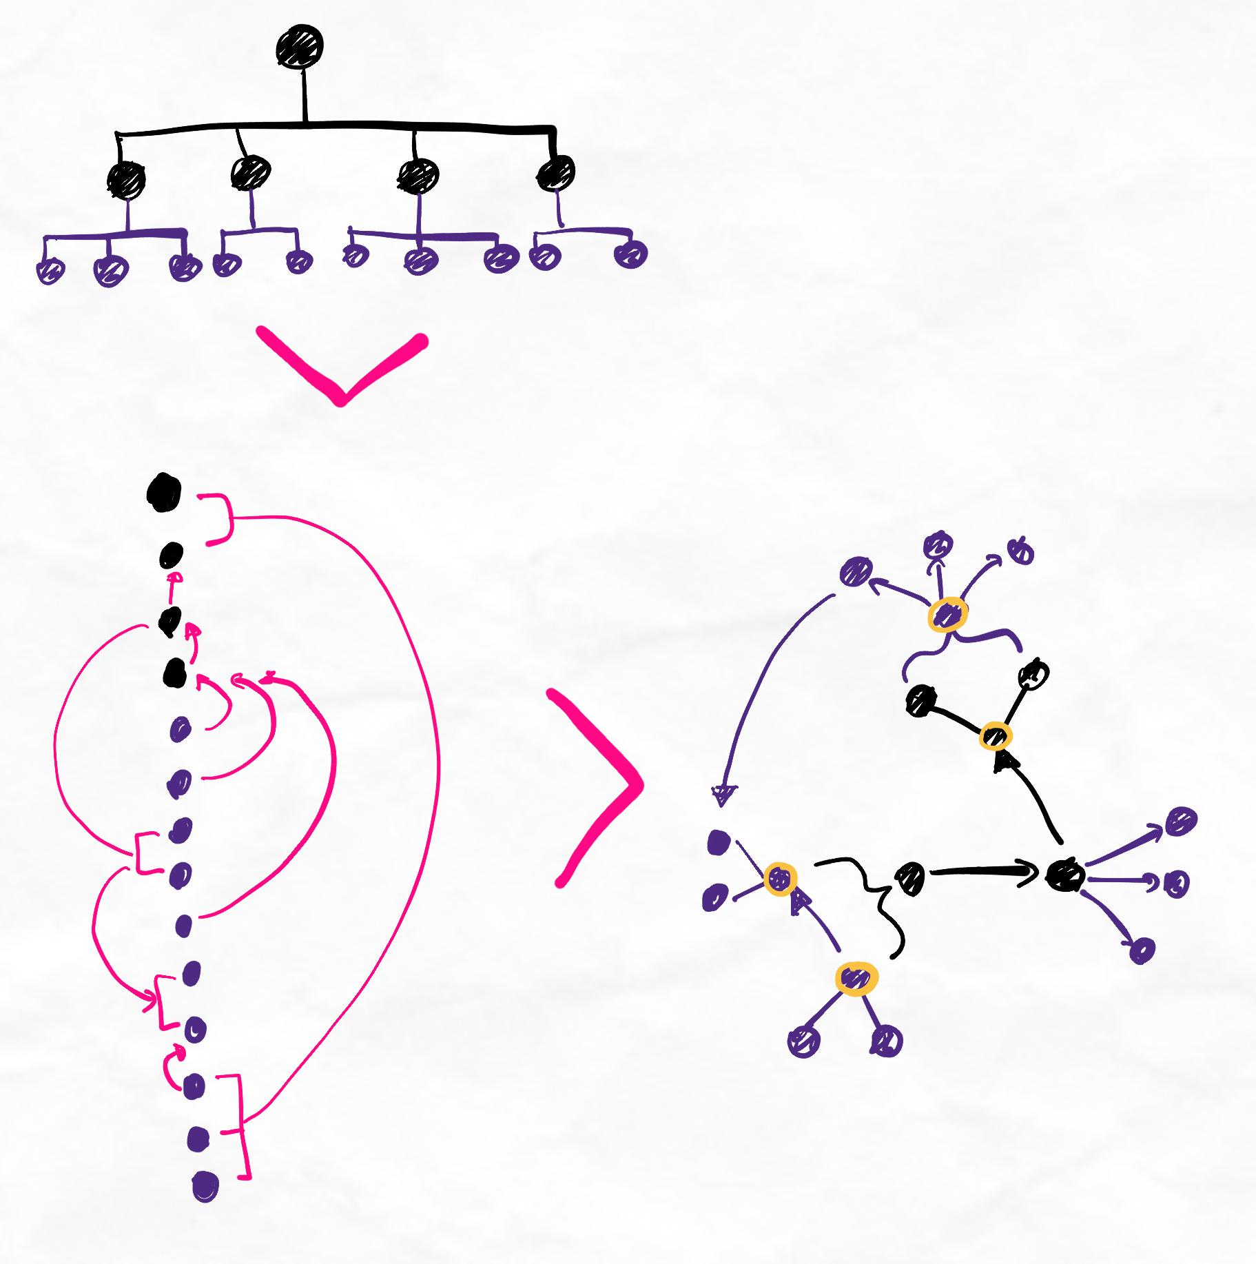
To avoid spiderwebbing...
- Regularly check that the overall chunk structure you are forming is the simplest and most intuitive.
- Whenever there are relationships between items that cause arrows and lines to become chaotic, think about if you could bring them closer or even into the same chunk.
- Avoid committing to a fixed chunk structure too early on. Stay open to changing your chunking structure if you need to.
- Avoid chunking in the exact same way as a textbook - this is often not the best way.
- Evaluate whether an arrow or line is necessary. Is the relationship important enough to express it? What is the nature of the relationship I'm trying to express?

